Food in Pompeii

Apparently the people of Pompeii enjoyed dining out or getting fast food. They did tend to eat at restaurants. They also had slaves that would cook high quality meals for them at home. I found they also usually ate bread, because it was a common and simple meal to make.
They ate bread, fine cheese, meat (mainly pork, beef or peacock), exotic fruit (especially purple grapes) and vegetables and a variety of fresh fish. Typically, they would drink high standard wine, water or milk from either a goat or a cow. For dessert they would have salad, cheese, cake or pie. At snack bars they could get hot pies, bacon, sausages, beans and even fried fish. The poor people though ate porridge, bread and maybe a stew (made from leftovers) once in a while and would only drink water from a well.
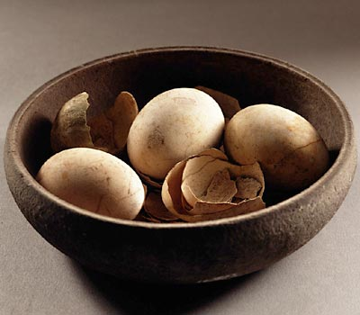
The eggs in this photograph were found during the excavations of Pompeii. Such finds are very rare, since organic materials generally have not survived.
It does appear from the available evidence, however, that the inhabitants of Pompeii had a varied diet. Other preserved foods that have been discovered include bread, walnuts, almonds, dates, figs and olives. Many animal bones (sheep, pig, and cattle), fish bones and shells (scallop, cockle, sea urchin, and cuttlefish) also have been uncovered.
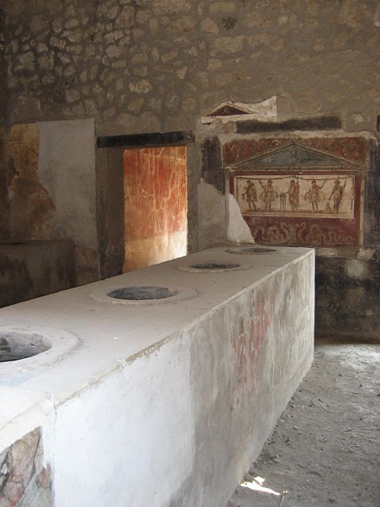
In just about the longest refurbishment period in history, the Pompeii based snack bar owned by Vetutius Placidus is to re-open. Its last customers left in something of a hurry one thousand nine hundred and twenty one years ago but the high profile launch tomorrow promises to be something of a more unhurried affair.
Three hundred specially invited guests are to taste the delights of Roman fast food in the thermopolium (that’s snack bar to you and me) in a special ceremony to mark the reopening of the joint, which has been closed to the general public for many years. Now after a long period of excavation and preservation, visitors will be able to once more taste the house specialty – baked cheese with lashings of honey.

The thermopolia were a standard feature of life in Pompeii – and indeed around the Roman Empire. There were over one hundred and twenty in the town, before it was enveloped by about sixty feet of pumice and ash and were remarkably similar to our own fast food joints of today. With one exception – most of the food was delicious and healthy. With the exception of the sweet desserts most of the food sold here would have been downright good for you –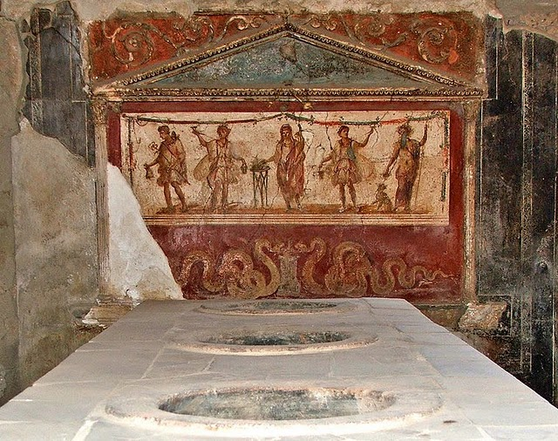

The thermopolia were so popular, in fact, that many of the houses in Pompeii lacked one room that we take for granted – a kitchen. The food was so cheap and available that it is thought that most Pompeians simply didn’t bother including a kitchen in their homes. Plus there is the fact that eating out was one of the most important social activities in Pompeii.
The shops were typically fairly small with large L shaped counters – just like shops today in fact that serve the same purpose. In to these counters large vessels would be sunk, that would then be used to contain the hot or cold pre-prepared food. The customers would take their food and pay for it at the counter. They could choose to eat it on the hoof or to eat it in the dining area – the triclinium. These rooms would be decorated with gorgeous frescos –

For those not in a hurry the triclinium offered a place to relax and chat with friends while the food was consumed. Below is a reproduction of how a triclinium would have typically looked.
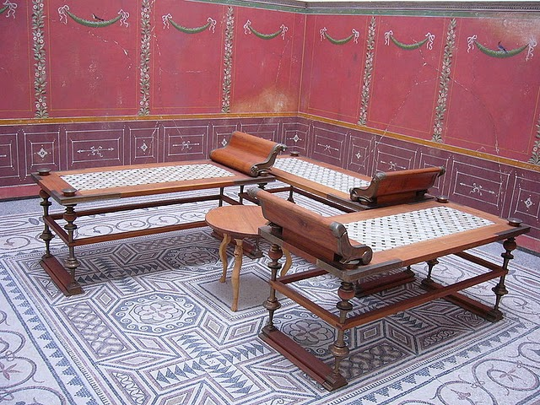

There was even an area called a viridarium, which was an enclosed garden, in which the customers could enjoy their lunch or dinner. Vetutius Placidus left a jar of coins with the last few days’ takings at the site. It can only be hoped that his newest customers spare him the occasional thought as they tuck in to their food.
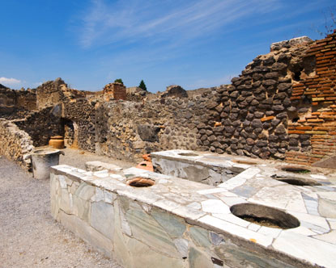
Cracked steps lead to a crumbling wall. Dull green wood mixes with red brick in what is left of this Pompeii restaurant, one of the main social gathering sites in the ancient city. Of all the tourist attractions in Italy, the ruins of Pompeii consistently draw visitors to its grounds, showing that although Roman ruins abound throughout the Western European country sides, you won’t see anything like you’ll find in Pompeii.
The town’s way of life has been referred to by historians as aimless, self-absorbed and vain. If there is any truth to this deconstruction of Pompeii history, we’ll likely never know, all we are left with is architectural remains devoid of context.
Any tour of the ruins will lead you to this Pompeii restaurant, which is notable as a popular meeting place, the first century equivalent of Roman nightlife. Here patrons would relax, play games (often ones reliant on the toss of the dice) and do what Italians have done for hundreds of years – feast. Even in ancient times, much of Italian culture is based around mealtime, where who you eat with is often more important that the contents of your dish. Since few of the houses in Pompeii showed any signs of having a kitchen, it’s likely that most of the town would come out to the Pompeii restaurant on a fairly regular basis, mingling with travellers, merchants and whoever else happened to be in town.
Before the eruption made the town into one of the most important tourist attractions in Italy, this restaurant was itself probably the town’s main draw.
One thing that researchers have done, however, is balance the mish-mash of surviving Pompeii artefacts with attempts to recreate the kinds of vegetables and fruits that were widespread throughout the city’s gardens before Vesuvius blanketed the town in ash. Hoping to add a little more realism into one of the most famous tourist attractions in Italy, visitors will now be able to amble through the ruins of the city surrounded by the staples of the ancient Roman diet: figs, olives and grapes will be found alongside the kind of vegetation that used to dominate the city – including exciting plants such as bramble, bloom and mallow.
Anyone who wants to dine on the same foods as found in Pompeii history can pick up packages full of these staple ingredients, along with recipes, hints and other related items. If you are lucky you may just be able to serve up some swallow’s tongue, a favourite dish of the upper class at Pompeii restaurants of the past. But most of the popular middle class dishes revolved around sharp vinegars, sweet fruits and cheeses and traditional recipes involving beans, fish and grains.
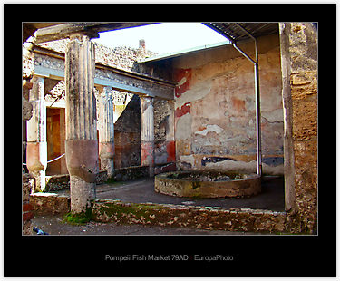
This apparently was a fish market with a huge pool from which you could select live, fresh fish.

Food in Ancient Rome

Food and Drink

For people dining in Ancient Rome, meals centred around corn (grain), oil and wine, and for the wealthy, different types of exotic foods. Cereals were the staple food, originally in the form of husked wheat (far) being made into porridge (puls), but later naked wheat (frumentum) was made into bread. Bread was the most often eaten food in Ancient Rome, and was sometimes sweetened with honey or cheese and was eaten with sausage, domestic fowl, game, eggs, fish, or shellfish.
Fish and oysters were especially popular, while meat, especially pork was also popular. Elsewhere in Rome, delicacies such as snails or dormice were specially bred. Varieties of cakes, pastries and tarts were made both commercially and at home, and were often sweetened with honey. Vegetables, such as cabbage and parsnips, lettuce, asparagus, onion, garlic, marrows, radishes, lentils, beans, and beets were imported. Fruits and nuts were also available, as was a variety of strongly flavoured sauces, spices and herbs, which became very popular in Roman cuisine. The only true literary source ever devoted to Roman food was a cookbook attributed to Apicus.

Romans loved wine, but they drank it watered down, spiced and heated. Undiluted wine was considered to be barbaric, and wine concentrate diluted with water was also common.
Pasca was probably popular among the lower classes. It was a drink made from watering down acetum, low quality wine similar to vinegar. Beer and mead were most commonly drunk in the northern provinces. Milk, mostly from sheep and goats, was considered to be barbaric and was therefore used for making cheese and medicine.

Cooking

Breads, cakes and pastries were cooked both commercially and at home. A circular domed oven was used mainly for bread and pastries. Mostly food was cooked over an open hearth, either by means of a cauldron suspended from chains, or cooking vessels seated on gridirons. Cooking was done in the kitchen where smoke could escape out a small hole in the ceiling, or through a wall vent. Some cooking was also done outside, and for those living in tenements, communal ovens may have been available.
Food was often prepared with a mixture of fruit, honey and vinegar, to obtain a sweet and sour flavour, and most meat was broiled. Food was difficult to preserve , and so popular foods like fish and shellfish was probably shipped live to their destination. Meat and fish could be preserved after a tedious process of pickling, drying, smoking, and salting. Food poisoning was probably common.

Meals

Romans generally ate one large meal a day.

Breakfast (ientaculum), if eaten, was a light meal at best, often consisting of nothing more than a piece of bread.

This was followed by the main meal of dinner (cena) at midday,

and a small supper (vesperna) in the evening.

Later it came to pass that dinner was eaten as a large meal in the evening, replacing supper and adding a light lunch or prandium.
For the poor, meals consisted of porridge or bread with meat and vegetables if available. For the wealthy the meal was divided into three courses (ab ovo usque ad mala - from egg to apples). The first was an appetizer made simple of eggs, fish shellfish, and raw vegetables known as gustatio or promulsis. The main course, prima mensa, consisted of cooked vegetables and meats, based on what the family could afford, and was followed by a desert (secunda mensa) of fruit and/or pastries.
The Romans sat upright to eat, while the wealthy often reclined on couches at dinner parties, or ate outside in gardens, weather permitting. For the poor, tableware probably consisted of coarse pottery, but for those who didn't mind spending some money, tableware consisted of glass, fine pottery, bronze, silver, gold and pewter.
Food was eaten with the fingers and cut with knives crafted from antler, wood, or bronze with an iron blade. Bronze, silver, and bone spoons were used to eat eggs and liquids. These spoons had pointed handles that could be used to extract shellfish and snails from their shells.

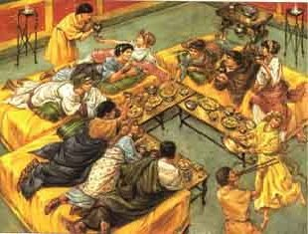

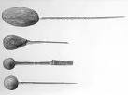

Different styles of Ancient Roman spoons. Note the pointy tips used to eat shellfish and snails.

From “A Taste of Ancient Rome”
http://books.google.com/books?id=KVbBA3x9wW0C&pg=PA122&lpg=PA122&dq=fish+species+eaten+in+ancient+rome&source=bl&ots=03D1CElAfR&sig=uwwZCgum8W4acjqcXFAqDbkK_VQ&hl=en&ei=bdHMTLzGG43BcaDIgaQO&sa=X&oi=book_result&ct=result&resnum=10&sqi=2&ved=0CDoQ6AEwCQ#v=onepage&q&f=false
From Chpt 8 Fish and Shellfish
Whenever a species became hard to capture from the seas they were farmed commercially in fish farms –piscinae until stocks recovered.
Fish were usually eaten fresh, or salted by salsamentarii or smoked.
The flavour of fish was so popular that garum, fermented fish sauce was used in almost every meal
Fine Fish were approximately twice the price for pork and triple the cost of beef or sheep
Species include
- Gudgeon
- Gilthead –esteemed North African species raised in captivity
- Molluscs
- Moray eels- raised in captivity (remember the novel Pompeii?)
- Scari (?) –very popular eastern Mediterranean species in early empire ,raised to stock the western half (!)
- Lobsters ,Crabs and all other crustaceans
- Tuna
- Cuttlefish, Octopus and Squid
- Red mullet –Very popular and sometimes extremely expensive
- Shellfish ,especially oysters mussels and clams

